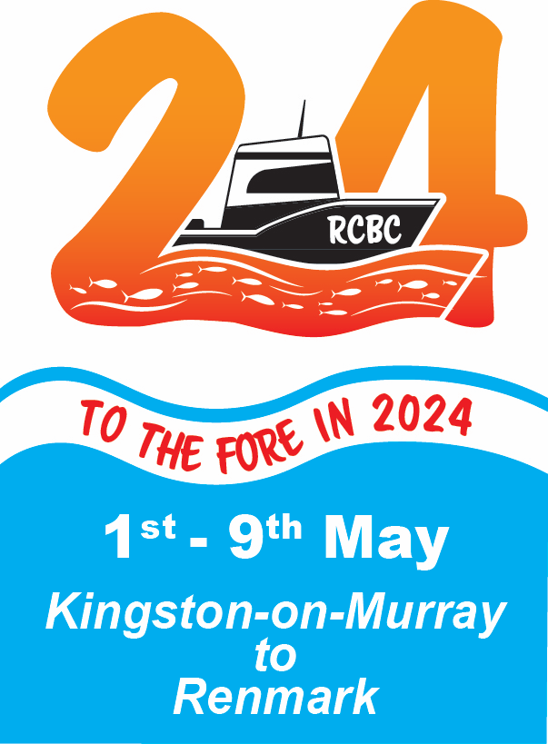

[riverlandcruisingboatclub.org.au](http://riverlandcruisingboatclub.org.au)

**RCBC River Run - Kingston-on-Murray to Renmark**

**1- 9 May 2024**

**Event Coordinators:** Paul (0412 661 733; [pknifton@bigpond.com](mailto:pknifton@bigpond.com)) and Judy Knifton;

Lindsay Dent (0421 493 397; [lindsay.dent27@gmail.com](mailto:lindsay.dent27@gmail.com))

This extended cruise takes in many of our picturesque Riverland towns and some beautiful stretches of the Murray River National Park. It is suitable for anything from open boats equipped for camping to cruisers and houseboats. We will have the luxury of catered meals (optional) at five of our stops. Adding to the soft life, will have the amenities trailer at three of our camps and full caravan park facilities at our final stop in Renmark. Otherwise there will be bush camping and campfire cooking at Raines Bend, Whirlpool Bend and Lyrup Flats. Our layover day will be at Whirlpool Bend, where there will be many opportunities for canoeing, kayaking and mucking about in tinnies. Each day is a short run, so there will be plenty of time for relaxing, exercise and exploring the towns, as you please. As usual, we will have some games, competitions and opportunities to perform (in more ways than one). We have also booked in to the Loxton Historical Village for an extended visit.

This River Run covers a total distance of approximately 130km, but some may wish to do it as an out-and-back return trip. Car parking at both ends and driver shuffles have been organized, but must be booked. Replenishment of fuel, food and drinks will be possible along the route, with car-based support in some locations.

Our designated charity for this event is the Moorook Kingston-on-Murray Community Association (MKOMCA) for their work in flood recovery. MKOMCA have provided volunteer labour and materials to rehabilitate gardens of recently widowed local women and they are also rehabilitating 18km of riverside trails built by this group prior to the 2022-3 flood.

Fruit fly restrictions apply within South Australia and as at time of publication, within the Riverland. More information on this is available on-line and links to this are presented on page 6.

Please bring a prize to be contributed to our fundraising raffles - more information on Page 4.

**Registration Deadline: 1 April 2024**

See:

* Page 3 for Running Sheet (Programme)
* Page 4 for Registration Details, Inclusions and Exclusions
* Page 5 for Registration for Optional Activities and Payment of Fees
* Page 6 for Additional Information On-line and Draw A Picture

[riverlandcruisingboatclub.org.au](http://riverlandcruisingboatclub.org.au)

**Running Sheet** (all distances are approximate)

**Wednesday, 1 May** **Gather at Kingston River Front**, car, trailer and driver shuffle to storage areas.

Club-sponsored BBQ at Moorook Hall (catered by MKOMCA, cost covered by Registration, optional, but must be booked on Registration Form). Donated wine, otherwise BYO.

**Thursday 2 May** **Leave Kingston and travel to Moorook** (16 km)

Optional dinner at Moorook Bowling Club $25/head: 2 roast meats, veggies, fish for those who prefer it, hot dessert, must be booked with registration.

Amenities trailer available (cost covered by registration)

**Friday 3 May** **Leave Moorook and travel to Raines Bend** (20 km)

Self-cater evening meal

Trivia Quiz 1. We are looking for a quiz master/mistress/dominatrix for each of three evenings, so get thunkin now.

**Saturday 4 May** **Leave Raines Bend and travel to Loxton** (17 km)

Tour Loxton Historical Village, $12/head (optional, at own cost), ice creams, drinks etc. available, but not lunch, BYO picnic lunch. Booking required via registration.

Dinner at Loxton Hotel (optional, at own cost).

Amenities trailer available (cost covered by registration)

What the Duck? The famous on-river event that will test both boat handling ability and sanity.

**Sunday 5 May** **Leave Loxton and travel to Whirlpool Bend** (staying 2 nights (22 km)

Self-catering

Red Faces - the tradition of embarrassment, show-ponying and musical mayhem continues. Prepare your performance, ditty, song or other party piece now. This can be a team event. Prizes will be awarded.

**Monday 6 May** **Day 2, Lay Day at Whirlpool Bend**; Kayaking/Fishing etc at this location

Self-catering

Trivia Quiz 2.

**Tuesday 7 May** **Leave Whirlpool Bend and travel to Berri** (15 km)

Takeaway Pizza dinner or Berri Hotel, TBA (optional, at own cost)

**Wednesday 8 May** **Leave Berri and travel to Lyrup Flats - Murray River National Park** (16 kms)

Self-Cater (camping fees included in registration)

Amenities trailer available (cost covered by registration)

Trivia Quiz 3. Your last chance to show your brilliance.

**Thursday 9 May** **Leave Lyrup Flats and travel to Renmark, Riverbend Caravan Park** (24 kms)

Mooring and camping fees covered by registration.

Car, trailer and driver shuffles as required (cost covered by registration)

Final dinner at Caravan Park as takeaway from Jimmy’s Thai or other (optional, own expense)

Announcement of Archieboat, Anuva and Waterlouse Art Prizes

**END OF RUN**

**Friday 10 May** **Car, trailer and driver shuffles may continue**, otherwise pack up and go home (or elsewhere).

See:

* Page 4 for Registration Details, Inclusions and Exclusions
* Page 5 for Registration for Optional Activities and Payment of Fees
* Page 6 for Additional Information On-line and Draw A Picture

[riverlandcruisingboatclub.org.au](http://riverlandcruisingboatclub.org.au)

**REGISTRATION DETAILS - please complete all sections**

**Name of Corresponding Participant** -

**Phone Number** - **Email Address** -

**BOAT, CAR AND TRAILER DETAIL**S (please circle where appropriate):

**Are you bringing a boat?** YES / NO **Will you require a place on another boat?** YES / NO

(Please note that it may not be possible to place you on another boat and this must be negotiated by you with the owner)

**Boat name and registration number** - **Type of Boat** -

**Approx. dimensions of boat** - LOA (m) Beam (m)

**Trailer Registration Number** - **Car Registration Number** -

**Do you require a car/trailer/driver shuffle?** (please circle) YES / NO If YES, please specify requirement i.e. storage at Kingston-on-Murray or Renmark (Caravan Park) - please circle

**Will you be bringing a canoe/kayak/tinny?** YES / NO If YES, type?

**Are you planning a caravan/camping tag-along where possible?** (e.g K-o-M, Moorook, Loxton, Berri, Lyrup Flats, Renmark) YES / NO If YES, type? If you are doing a tag-along, please note that you may be responsible for your own camping fees in K-o-M, Moorook, Berri.

**INCLUSIONS AND EXCLUSIONS IN YOUR REGISTRATION FEE**

Your registration fee **includes**: 2024 River Runners’ bag containing - burgee, information booklet, name badge, printed maps and brochures where available; use of RCBC facilities including Amenities trailer and consumables (e.g. gas, water, soap and detergents, hand sanitizer, paper products, first aid supplies (if required); catered BBQ at K-o-M Hall (1 May); *general camping and mooring fees at Lyrup Flats and Renmark Riverbend Caravan Park; car and trailer transfers facilitated by volunteer drivers.

**Exclusions**: catered meal at Moorook Bowling Club, takeaway, food van, restaurant or hotel meals at Loxton, Berri and Renmark. *We have booked 5 riverfront camping/caravan sites at the Renmark Riverbend Caravan Park and these are available on a first-registered-first-served basis. Other sites in the park may be booked separately at your own cost. Five waterfront/pet friendly cabins have also been included in our booking and these have been paid for in advance by the persons requesting cabins. These bookings have been made to ensure that we have sufficient riverbank for exclusive mooring of our fleet. All other booking in caravan parks and camping grounds are at your own cost. The RCBC carries limited insurance for our activities and this does not cover insurance for your car, trailer or boat.

**Raffle/Prizes for our designated charity - The Moorook Kingston-on-Murray Community Assoc.**

The RCBC has a long history of donating to charities relevant to the Riverland, young people, boaties and/or boating. Traditionally this has been done mostly through a major (and labour-intensive) auction associated with the River Run. This is beyond the resources of our Club these days, but we endeavour to keep up the philanthropic tradition by raising money through raffles and games held during events. These are a fun part of our activities. If you can, please bring a prize for a raffle or mini-auction. Raffle prizes should be valued at no more than $50 and can be mystery prizes (wrapped) or displayed to demonstrate their true worth. Prizes can be new, recycled or re-purposed, humorous or serious, but should not be too big because you will need to carry your donation on your boat and so will the winners. Our sponsors and commercial friends will also make contributions. Please also bring some spare cash so that you can participate in the nightly raffle draws and IOUs will be accepted if we have a mini-auction or two. You can see more about our contributions to charities at <http://riverlandcruisingboatclub.org.au/aboutus/blank-5/>

See:

* Page 5 for Registration for Optional Activities and Payment of Fees
* Page 6 for Additional Information On-line and Draw A Picture

**REGISTRATION FOR OPTIONAL ACTIVITIES AND PAYMENT OF FEES**

**Names of ALL participants** [at $110/boat including (one) skipper, add $70 for each additional person (i.e. other half/better half/crew/the real skipper), payable to RCBC account]:

a) b)

c) d)

**DO YOU WISH TO PARTICIPATE IN THE FOLLOWING OPTIONAL ACTIVITIES?**

Kingston-on-Murray BBQ (included in registration) YES / NO If YES, no. persons

Meal Moorook Bowling Club (own cost, $25pp, **payable with registration**) YES / NO. If YES, no. persons

Visit to Loxton Historical Village ($12pp, payable on the day) YES / NO. If YES, no. persons

**Summary - Total RCBC Registration Fee ($):**

**Meal at Moorook Bowling Club ($25pp, payable now):**

**TOTAL FEES PAYABLE TO RCBC:**

Preferred Payment Method: Payment should be made by bank transfer (Electronic Funds Transfer) to

Riverland Cruising Boat Club Inc: BSB: 105052 Account: 50489140 (Bank SA)

**Include your family name and 2024RR**

If this is not possible, please post a cheque, payable to the Riverland Cruising Boat Club, accompanied by your Registration Form to: Lindsay Dent, 27 Tapson Crs., Pasadena, South Australia, 5042.

**Return your form to Lindsay Dent by email of possible (**[**lindsay.dent27@gmail.com**](mailto:lindsay.dent27@gmail.com)**) or post (see above) by Tuesday 2 APRIL 2024**

**GENERAL INFORMATION**

RCBC insurances do not cover your boat or any damage it may cause. We expect that you carry appropriate insurance.

A medical form is attached with this registration form. Please complete and hand it to a coordinator on arrival (not opened except in the case of emergency, can be recovered at the end of the event).

**CONFIRMATIONS:**

 I / We have all safety equipment necessary for this event.

 I / We will bring an envelope with our medical form, only to be opened in an emergency.

 I / We agree that all crew/passengers will comply with all COVID Safe restrictions in place at the

time of the event, and all directions of the Committee in relation to COVID Safety.

 I / We agree that if exhibiting symptoms of COVID 19, we will only attend if we have recently

tested negative for it and will practice social distancing until symptom-free. Refunds available if

required.

**SIGNATURE OF CORRESPONDING PARTICIPANT:** **DATE:**

**YOUR COMMENTS AND/OR QUESTIONS**……………..

See Page 6 for Additional Information On-line and Draw A Picture

[riverlandcruisingboatclub.org.au](http://riverlandcruisingboatclub.org.au)

**ADDITIONAL INFORMATION AVAILABLE ON-LINE:**

**Movement of fruit and vegetable restrictions - INTO the Riverland from other parts of South Australia**

<https://fruitfly.sa.gov.au/outbreak-restrictions/fruit-and-vegetables-at-risk>

The current estimate for the end date for restrictions **WITHIN the Riverland outbreak areas** is 24 April 2024 (i.e. before the River Run, but end-dates have been extended previously - it only takes one fly).

**Pest-free areas** can be found using the interactive map at:

<https://fruitfly.sa.gov.au/outbreak-map>

As at the time of dispatch of this Registration Form (14 February 2024), Kingston-on-Murray, Moorook and parts of Loxton and Waikerie, are outside of the Red restricted zones, but in the Yellow zones. However the store in K-o-M is now closed and the Moorook store does not stock fruit and veg. Transfer of fruit and veg. from Yellow areas to any other Yellow or Red area is permitted if purchased at a shop (permanent retail business), with an itemised receipt. You must seal fruit and vegetables in a bag or container while moving them. Stores at Walker Flat, Swan Reach and Blanchetown had endeavoured to expand their range and specific stores in Murray Bridge and Mannum were accredited for movement of fruit into the Riverland. Berri and Renmark are inside the restricted Red zones.

For more on this and options for shopping for fruit and veg. within or before entering the Riverland can be found at:

<https://fruitfly.sa.gov.au/travelling-restrictions/travelling-to-the-riverland/shopping_options_for_riverland_residents_and_regular_visitors>

You can find out more about the Riverland at

[riverlandcruisingboatclub.org.au](http://riverlandcruisingboatclub.com.au) and <https://southaustralia.com/destinations/riverland>

and <https://www.visitriverland.com.au/>

**DRAW A PICTURE below** of your favourite boat, person, river scene, plant or animal. These will be reproduced and prizes given to commemorate the peoples’ favourite artistic efforts. There will be The Archieboat Prize for a depiction of a boat or person (or combination thereof), The Anuva Prize for the best landscape and The Waterlouse Prize for art in the natural sciences.

[riverlandcruisingboatclub.org.au](http://riverlandcruisingboatclub.org.au)